# Q1.

## Part 1 and 2

**Result for simple way**

0.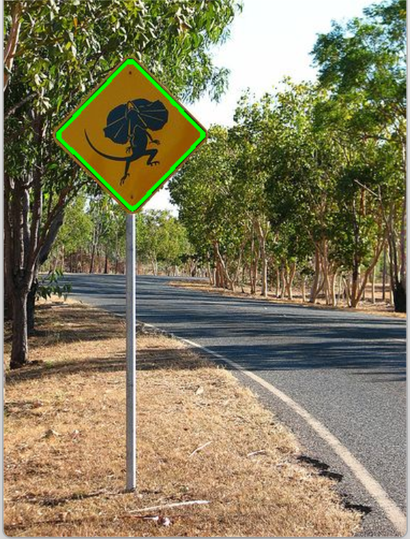

4.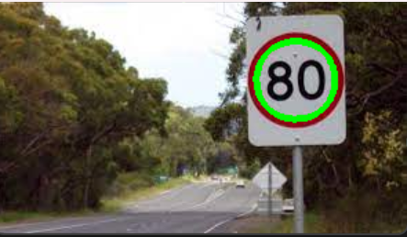

6. 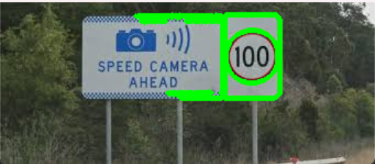

8. 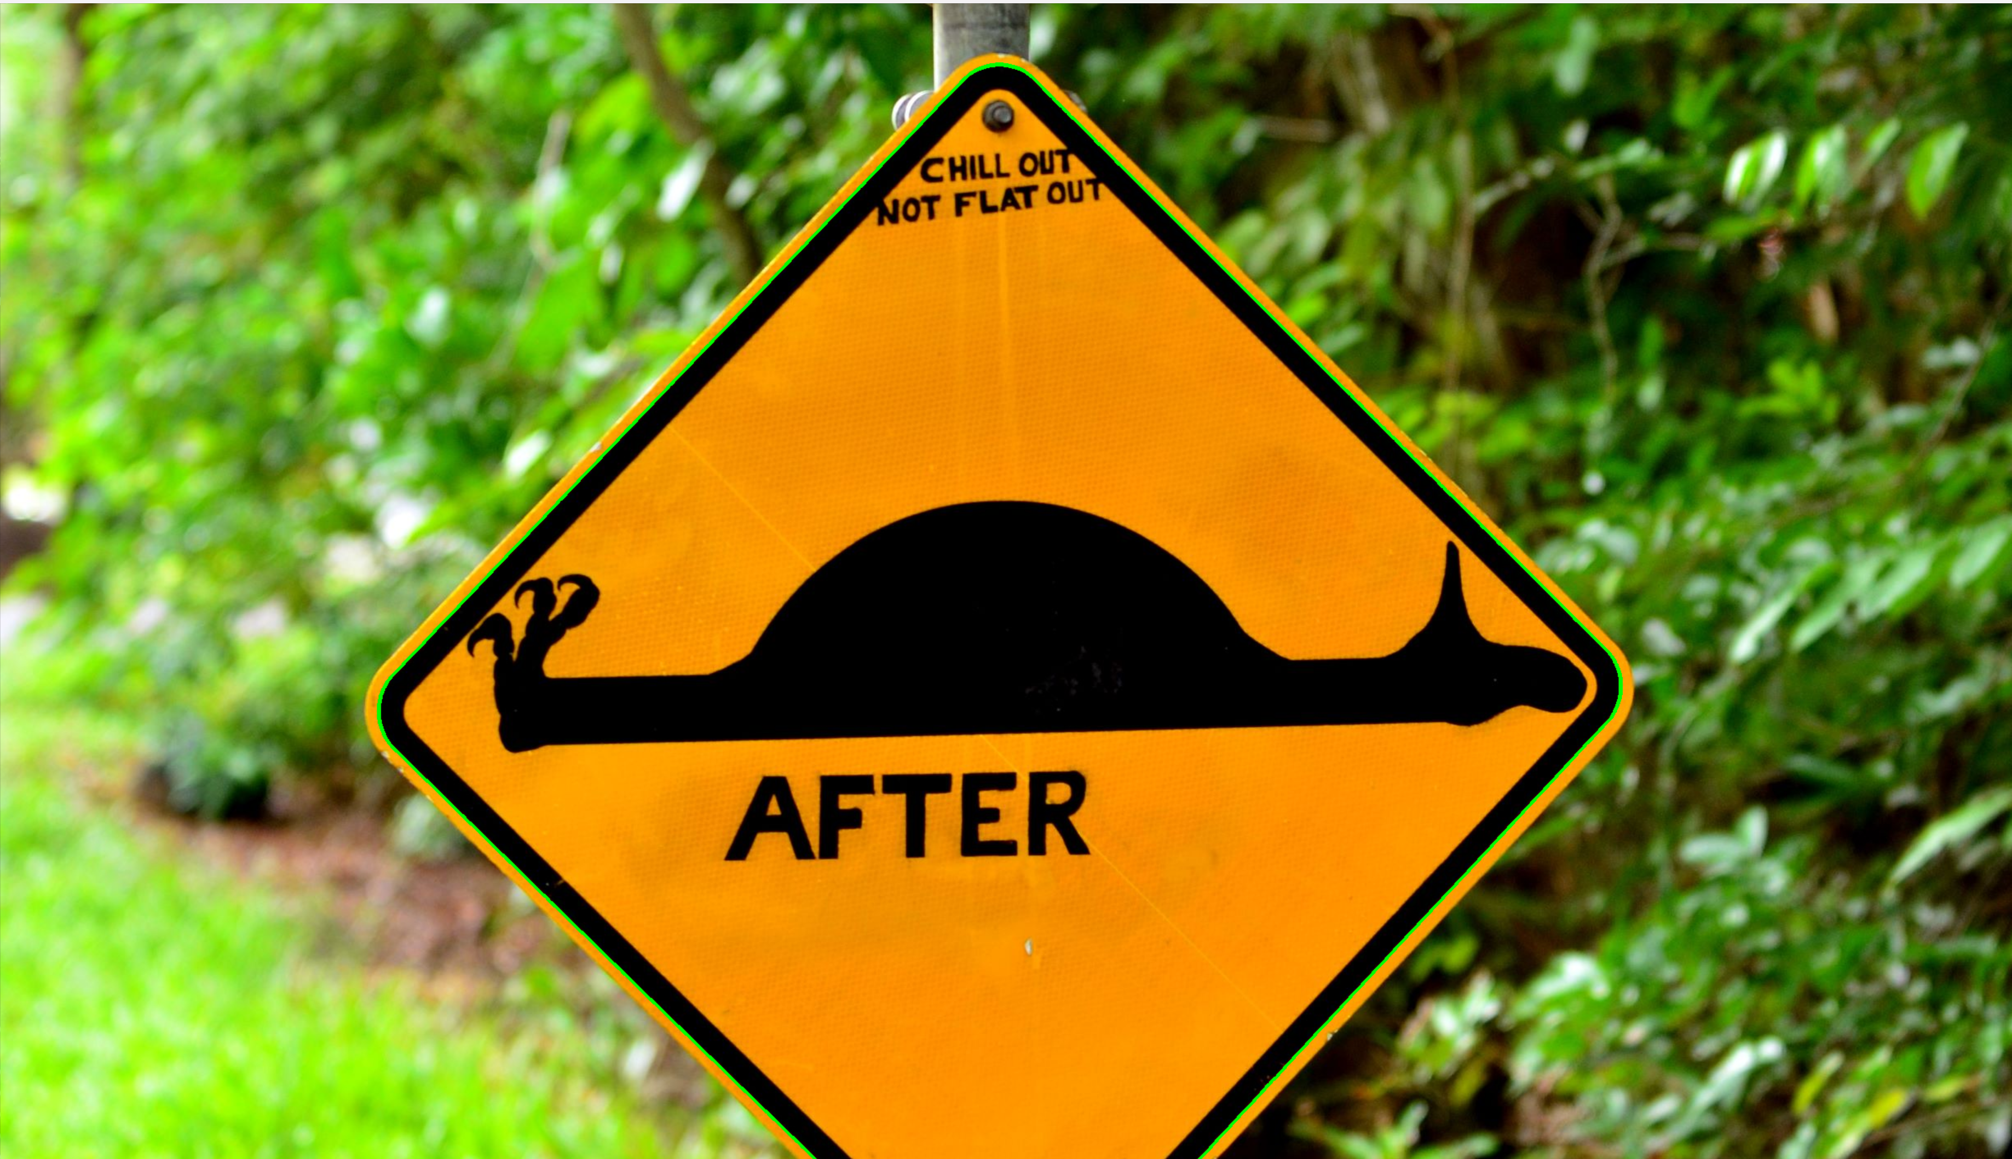

12. 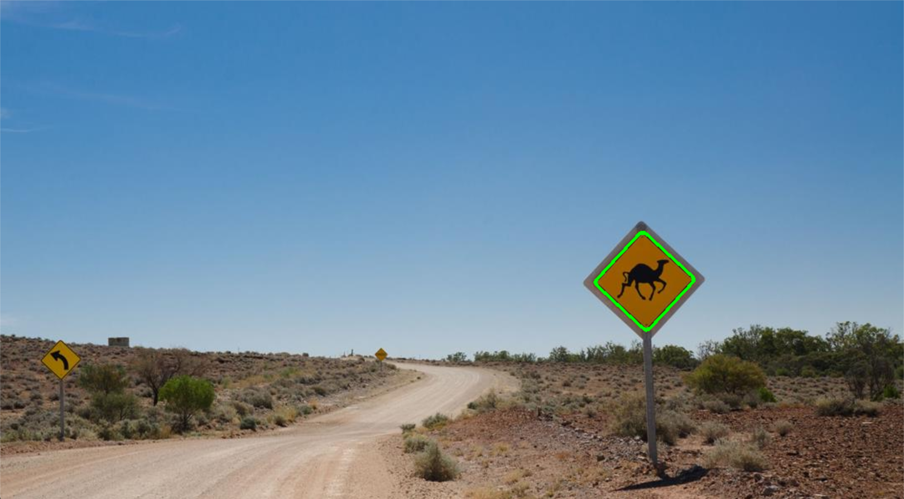

13. 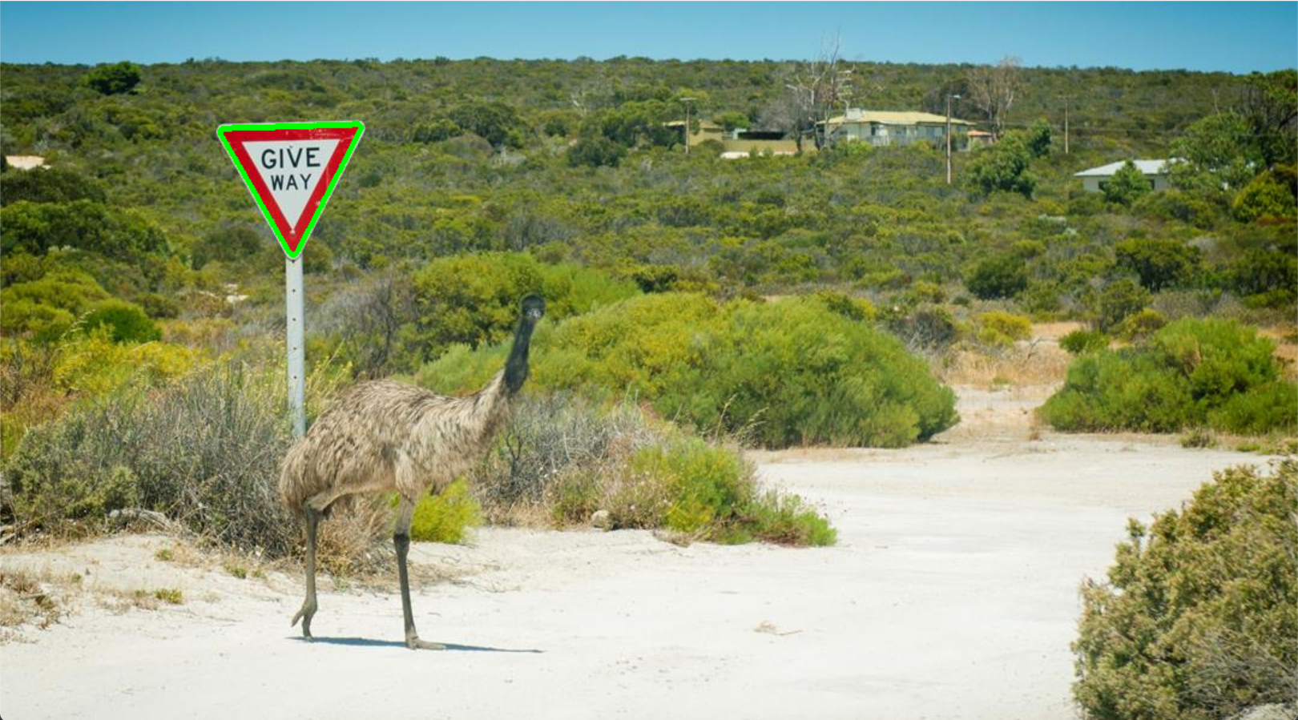

14.

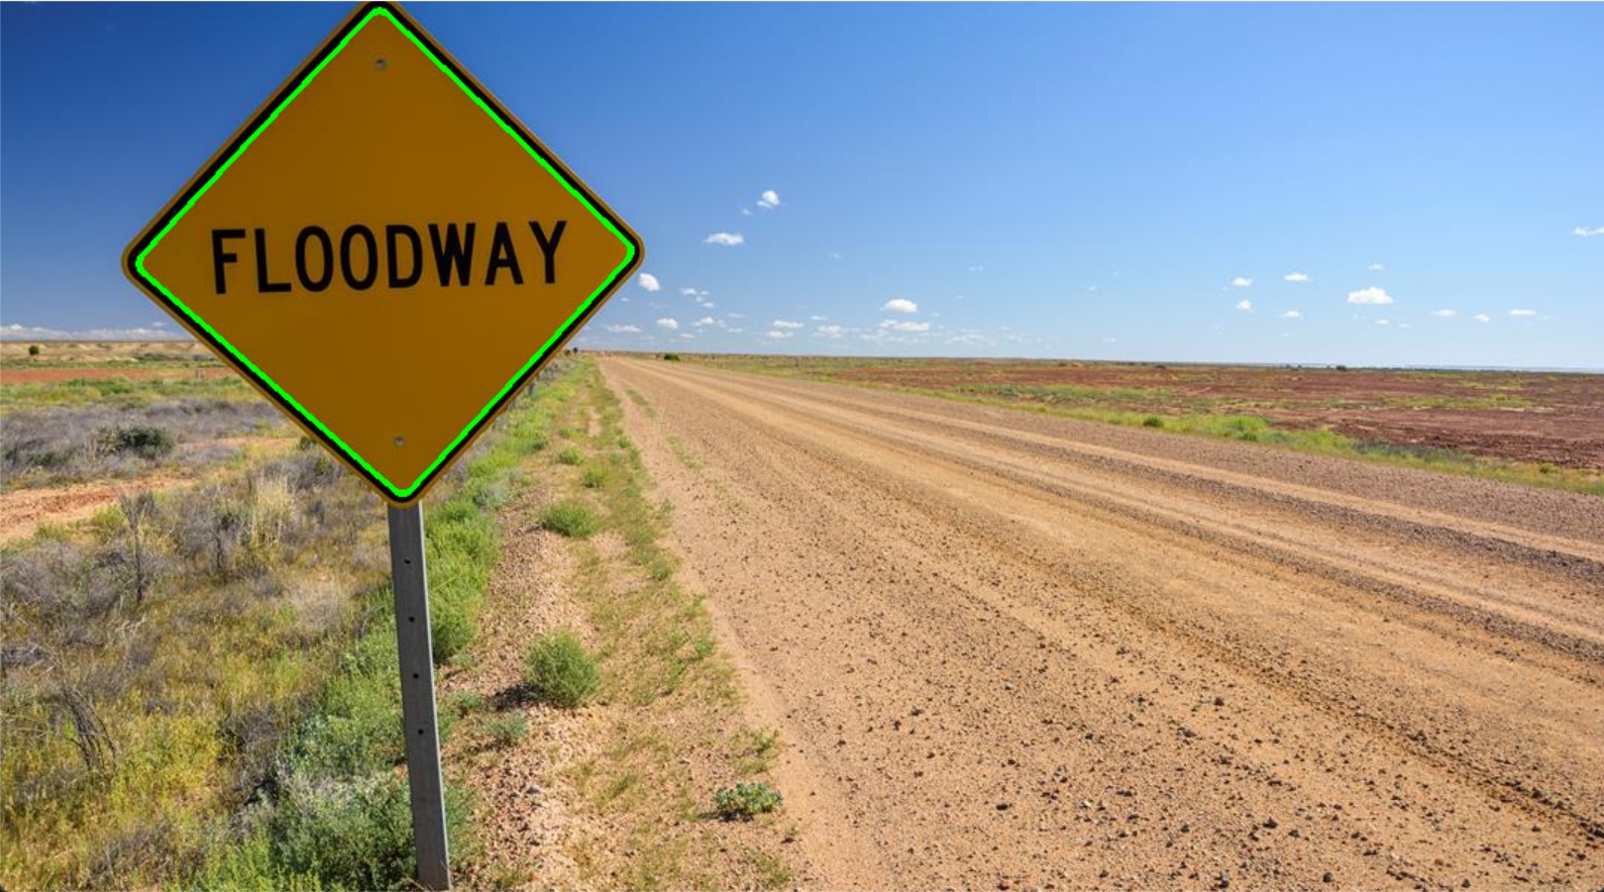

15.

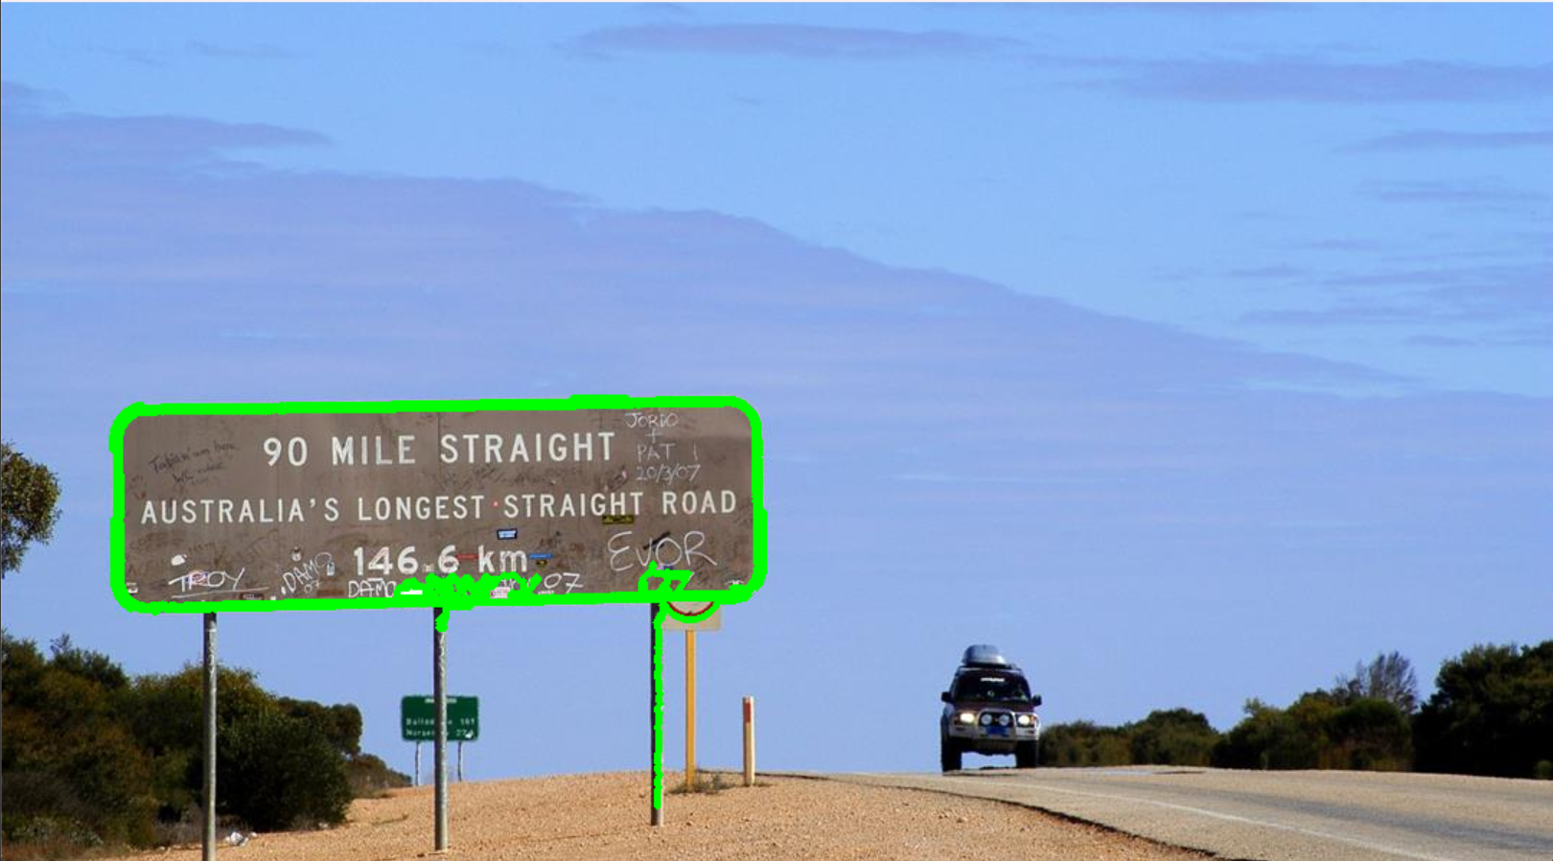

17.

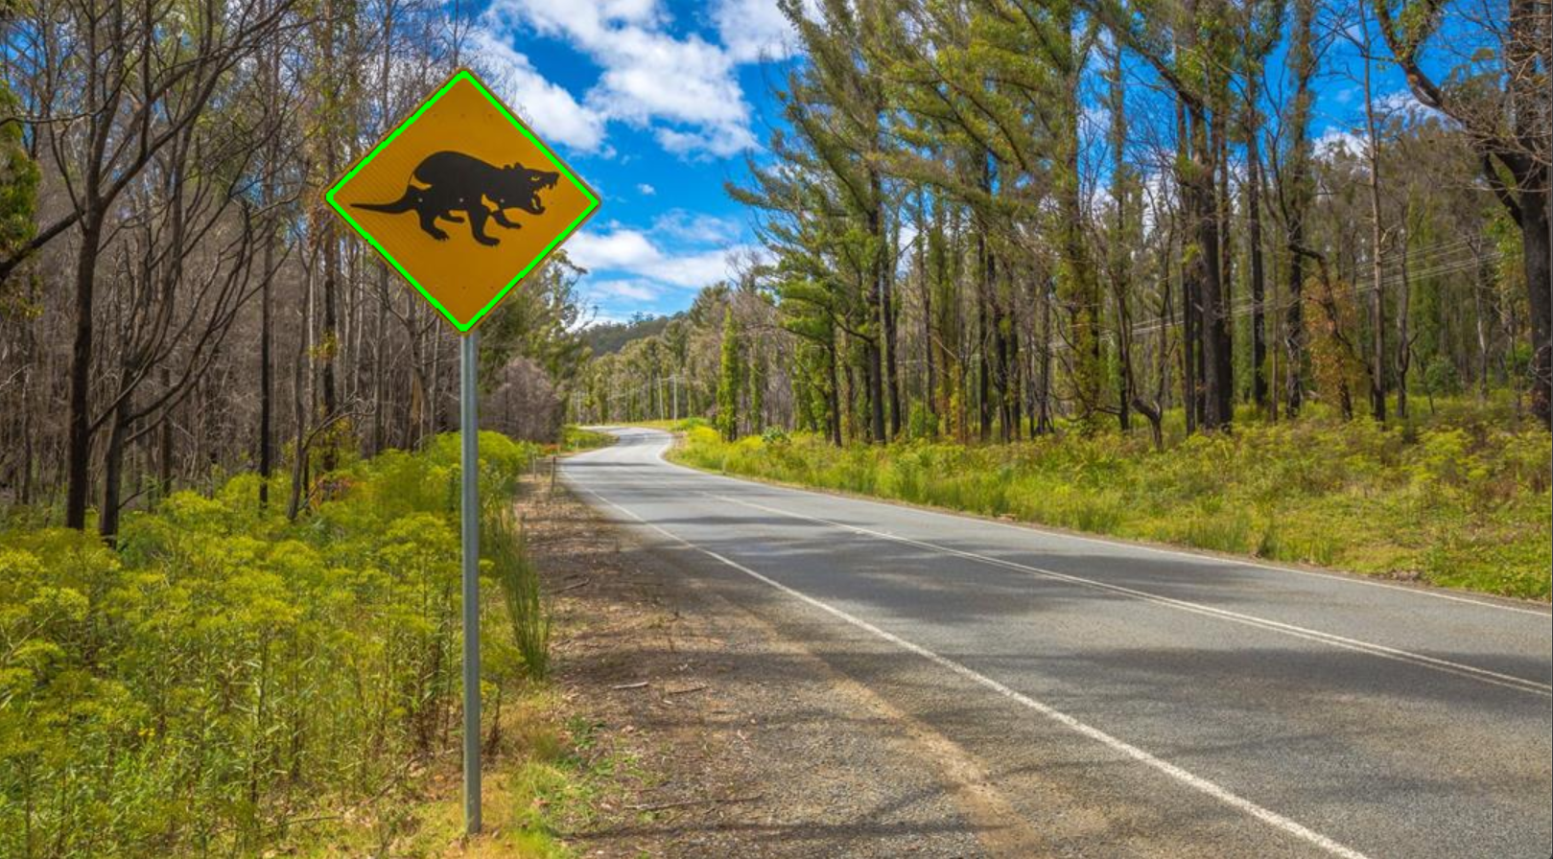

19.

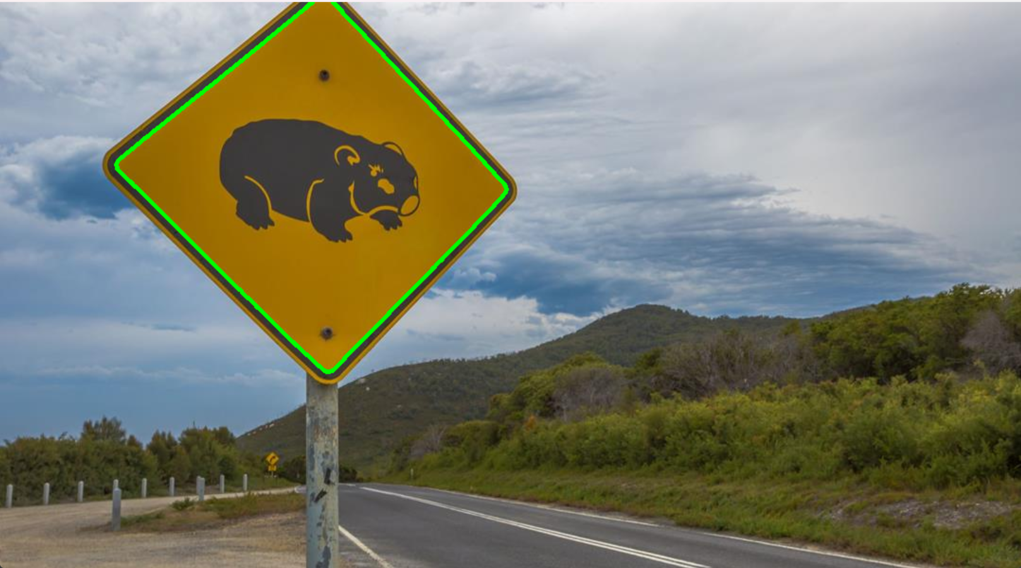

18.

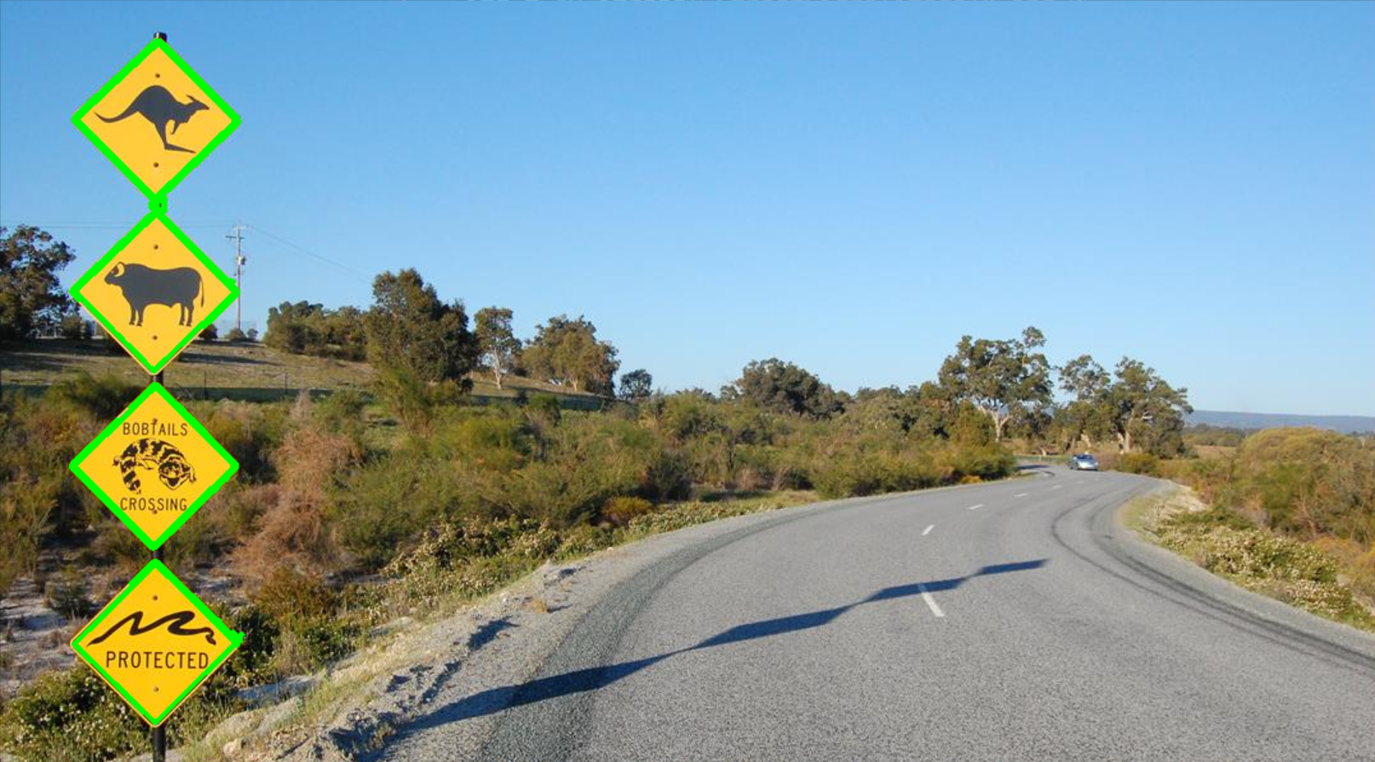

**Steps and Codes**

The above images are done by the following code.

Only the most basic processing was done:

1. Convert to greyscale to make the edges more visible
2. Detecting edges
3. Use the detected edges to find the outline
4. Finding the largest contour and filtering out the two-thirds of the contour that reaches the largest area.
5. Displaying these outlines

import numpy as np

import cv2 as cv

image_path = 'StreetSigns/image18.jpg'

original_image = cv.imread(image_path)

#Grayscale

grayscale_image = cv.cvtColor(original_image, cv.COLOR_BGR2GRAY)

# detect Edges, can adjust 100,200

edges_detected = cv.Canny(grayscale_image, 100, 200)

# find Contours

contours, hierarchy = cv.findContours(edges_detected, cv.RETR_TREE, cv.CHAIN_APPROX_SIMPLE)

# find highlight contours

largest_area = max(cv.contourArea(contour) for contour in contours)

significant_contour_threshold = largest_area * 2 / 3

# draw the contours

for contour in contours:

    if cv.contourArea(contour) >= significant_contour_threshold:

        cv.drawContours(original_image, [contour], -1, (0, 255, 0), 2)

# display the Results

cv.imshow('Significant Contours Highlighted', original_image)

cv.waitKey(0)

cv.destroyAllWindows()

**Modified**

1.

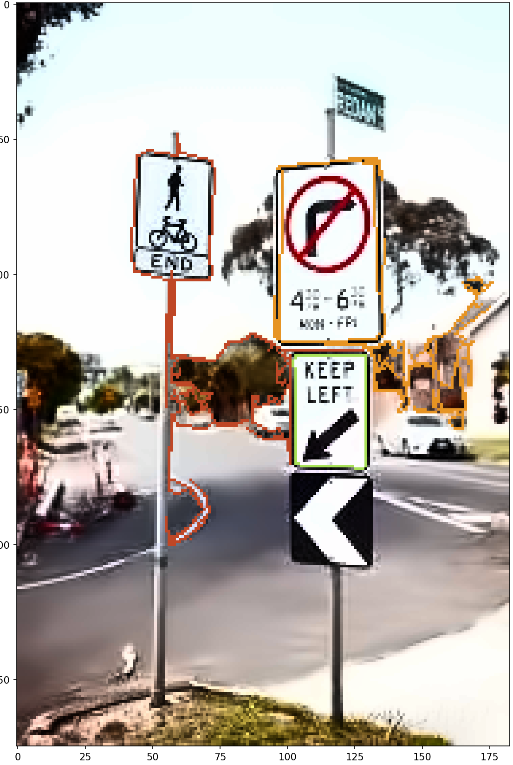

5.

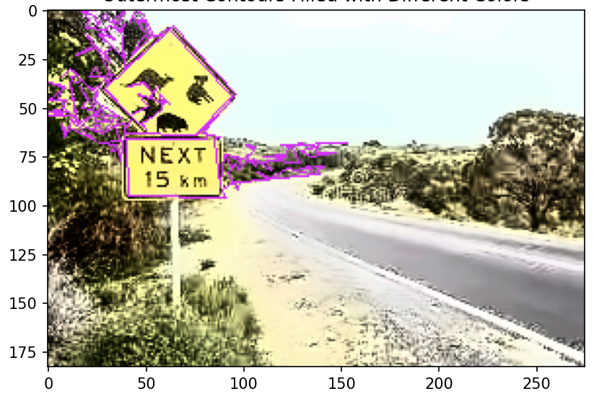

10.

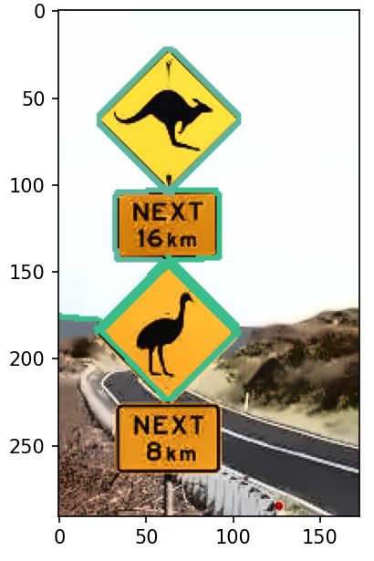

**Steps and Codes**

The above basic approach is not good for recognizing some images

So the code has been improved:

1. First adjust the brightness and contrast of the image
2. Then use the denoising algorithm
3. Next convert the image to grey scale and perform edge detection
4. Use the found edge to find the outline
5. If one contour wraps around the other then only the outermost contour is retained
6. Reduce the number of vertices in the outline
7. Filter out the contours that are larger than one third of the maximum area.
8. Draw these outlines using random colours

import cv2 as cv

import numpy as np

import matplotlib.pyplot as plt

img = cv.imread('StreetSigns/image1.jpg')

# color space to YUV for following adjustment

img_yuv = cv.cvtColor(img, cv.COLOR_BGR2YUV)

# brightness adjustment (Y channel)

img_yuv[:, :, 0] = cv.equalizeHist(img_yuv[:, :, 0])

# contrast adjustment

alpha = 1.78

img_yuv[:, :, 0] = cv.convertScaleAbs(img_yuv[:, :, 0], alpha=alpha)

# back to BGR

img_enhanced = cv.cvtColor(img_yuv, cv.COLOR_YUV2BGR)

# non-Local Means Denoising

img_non_local = cv.fastNlMeansDenoisingColored(img_enhanced, None, 11, 10, 7, 22)

# edge detection and find contour

gray = cv.cvtColor(img_non_local, cv.COLOR_BGR2GRAY)

v = np.median(gray)

sigma = 0.55

lower = int(max(0, (1.0 - sigma) * v))

upper = int(min(255, (1.0 + sigma) * v))

edges = cv.Canny(gray, lower, upper)

contours, hierarchy = cv.findContours(edges, cv.RETR_TREE, cv.CHAIN_APPROX_SIMPLE)

# retain the outermost contours

filtered_contours = [cnt for i, cnt in enumerate(contours) if hierarchy[0][i][3] == -1]

# approximate contours (reduce vertex count)

approx_contours = []

for cnt in filtered_contours:

    epsilon = 0.001 * cv.arcLength(cnt, True)

    approx_contours.append(cv.approxPolyDP(cnt, epsilon, True))

# maximum contour area

max_area = max(cv.contourArea(cnt) for cnt in approx_contours)

# filter contours

filtered_contours = [cnt for cnt in approx_contours if cv.contourArea(cnt) > max_area / 3]

# draw contours

img_with_contours = img_non_local.copy()

for cnt in filtered_contours:

    color = np.random.randint(0, 255, (3)).tolist()

    # contour outlines

    cv.drawContours(img_with_contours, [cnt], -1, color, 2)

    # fill the contours

    # cv.drawContours(img_with_contours, [cnt], -1, color, -1)

# display the result

plt.imshow(cv.cvtColor(img_with_contours, cv.COLOR_BGR2RGB))

plt.show()

## Part 3

The most serious problem encountered in detecting traffic signs is usually leaves, and most failed detections are due to leaves interfering with edge detection. And attempts to remove the effects of foliage are not very effective.

3. 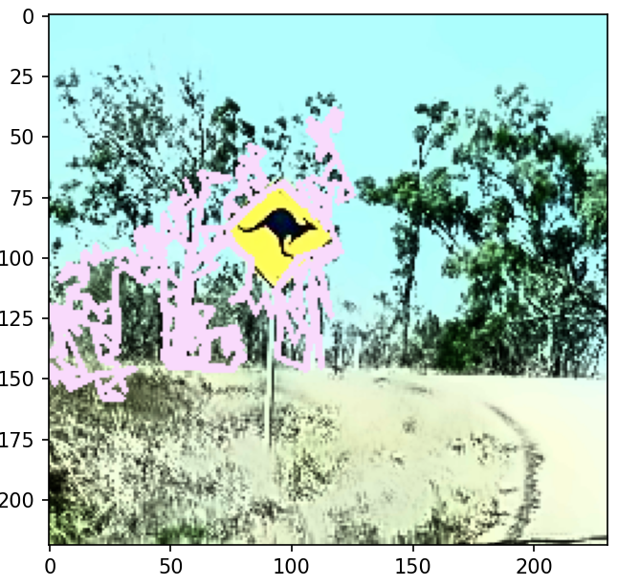 1. 

The first thing I noticed was that most of the traffic signs had black frames. So my initial idea was to highlight these boxes. I tried adjusting the brightness, the contrast and limiting the number of fixed points of the outlines, but these behaviours yielded some results, but they were not satisfactory.

To solve this problem I also tried to recognise only straight or diagonal lines, ignoring the irregular edges. But I found it very difficult to filter out the straight lines I needed. Due to the resolution of the image, the edges recognised were smaller line segments, which made them very difficult to distinguish.

I also tried to adjust the definition of a straight line such that an offset within a certain range could be considered as a straight line, but again the results were not satisfactory. I also tried sharpening the image before processing it, but the only result was more noise. Adding the denoising algorithms didn't have a very noticeable effect on the results, but they did make the traffic signs more visible in my opinion.

Another important factor is that some of the markers do not have clear boundaries and are not clearly distinguishable from the background.

This resulted in edge detection not being able to recognise these boundaries, and adjusting the sensitivity of the edge detection did not give the desired results. Since all these parameters interact with each other, adjusting a single parameter usually leads to new problems.

7.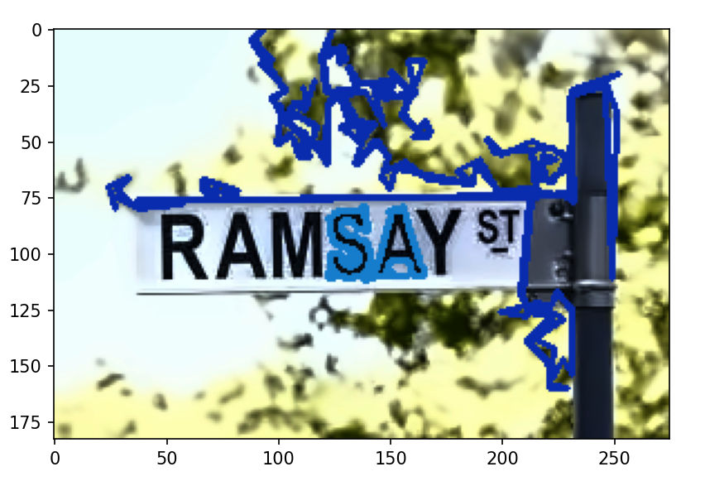16. 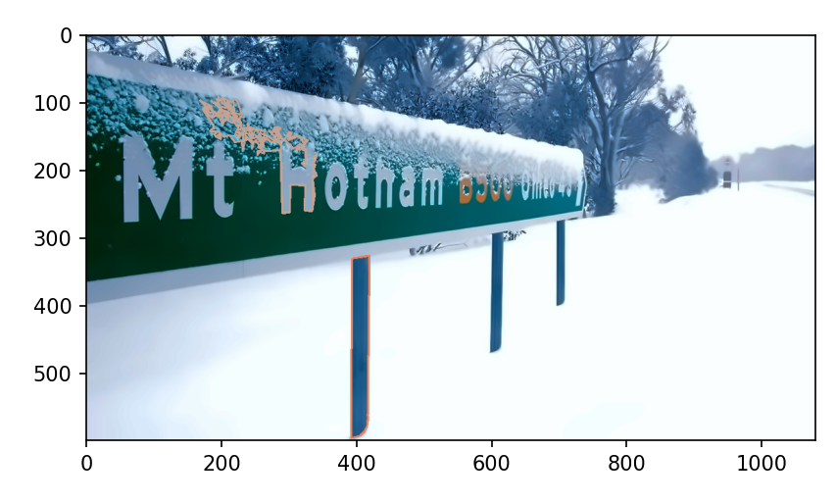

In addition to this, different shapes, lighting, colours and angles of road signs do not irreversibly affect the results. Because essentially sign recognition is about finding the edges and filtering out the ones we are interested in.

Based on the above difficulties, a possible solution is to identify the parts of the picture that have the same colour. Because the main feature of most of the traffic signs is a large single colour base and draw different signs in the centre. And combine it with edge detection to try to filter out the colours that are too cluttered. In addition to this another possible direction is to give up on accurately identifying all the edges of traffic signs. Instead identify the position the sign is in and draw a box based on that position.

# Q2.

## Part 1

**Steps**

The detection of intersections can be divided into the following steps

1. Firstly import the video
2. Take specific frames. Then perform image processing (grey scale picture and brightness to make the lines more visible)
3. Define our region of interest
4. Then find the line segments within this region
5. Next distinguish if they are horizontal or vertical (horizontal/vertical offset from start to end)
6. Then find the horizontal line segment with the largest y value (uppermost) and the vertical line segment with the smallest x value (leftmost)
7. Next calculate the intersection of their extension lines
8. Display

**Result**

The following image shows the intersection point found by the code:

3.3s

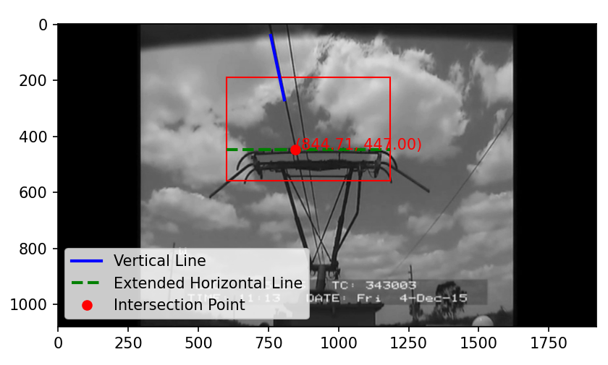

6.6s

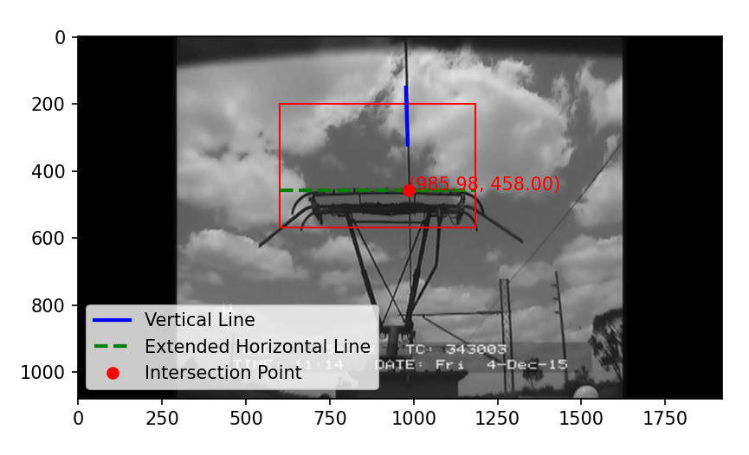

13.3s

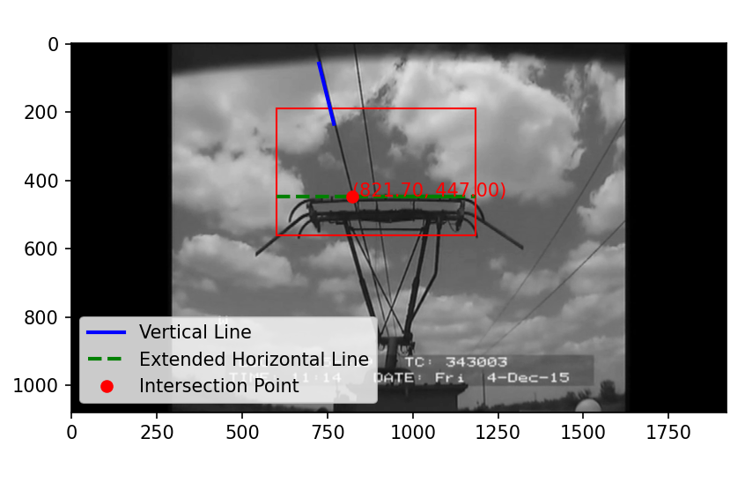

20s

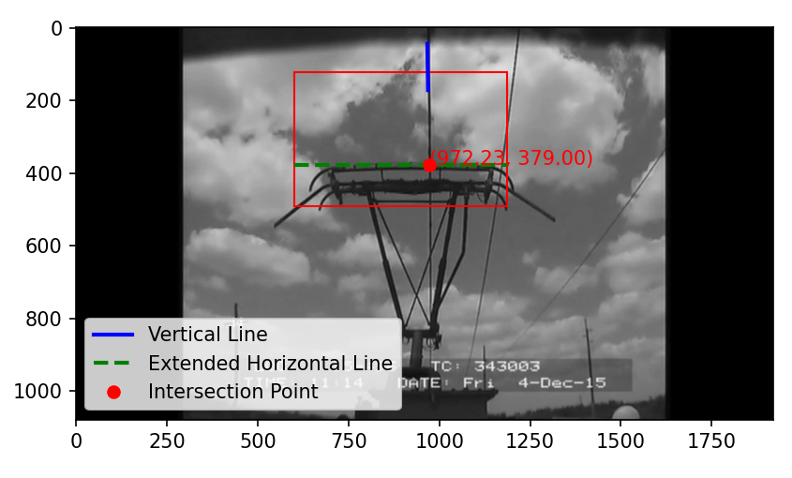

30s

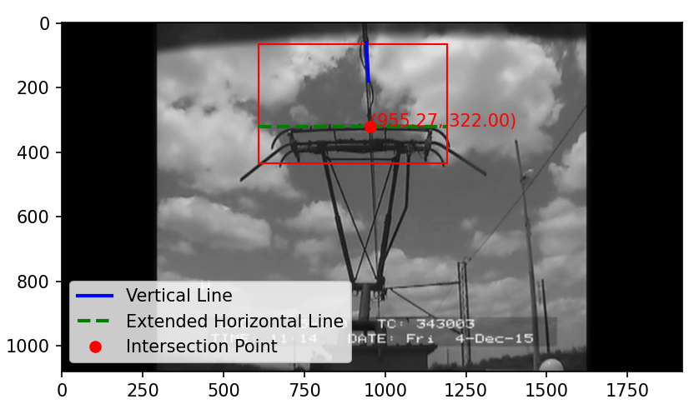

**Code**

import cv2

import numpy as np

import matplotlib.pyplot as plt

def is_inside_rectangle(x, y, rect_top_left, rect_bottom_right):

    return rect_top_left[0] <= x <= rect_bottom_right[0] and rect_top_left[1] <= y <= rect_bottom_right[1]

# load video

video = cv2.VideoCapture('Train/Panto2024.mp4')

if not video.isOpened():

    #print("error opening video file.")

    exit()

# test read

ret, frame_1 = video.read()

if not ret:

    #print("failed to find the first frame.")

    exit()

# grayscale and binarize

gray_frame_1 = cv2.cvtColor(frame_1, cv2.COLOR_BGR2GRAY)

_, binary_frame_1 = cv2.threshold(gray_frame_1, 83, 255, cv2.THRESH_BINARY)

# define a template

template = binary_frame_1[200:570, 600:1185]

top_left_template = (600, 400)

bottom_right_template = (top_left_template[0] + template.shape[1], top_left_template[1] + template.shape[0])

# select test frame (30 frame/s, total 38s )

video.set(cv2.CAP_PROP_POS_FRAMES, 100)

ret, frame_120 = video.read()

if not ret:

    #print("Failed to grab frame.")

    exit()

gray_frame_120 = cv2.cvtColor(frame_120, cv2.COLOR_BGR2GRAY)

_, binary_frame_120 = cv2.threshold(gray_frame_120, 83, 255, cv2.THRESH_BINARY)

# cross-correlation

result = cv2.matchTemplate(binary_frame_120.astype(np.float32), template.astype(np.float32), cv2.TM_CCORR_NORMED)

_, _, _, max_loc = cv2.minMaxLoc(result)

top_left = max_loc

bottom_right = (top_left[0] + template.shape[1], top_left[1] + template.shape[0])

# edge detection and hough transform

edges = cv2.Canny(binary_frame_120, 50, 150, apertureSize=3)

lines = cv2.HoughLinesP(edges, 1, np.pi / 180, threshold=100, minLineLength=100, maxLineGap=20)

# find the highest horizontal line segment and the leftmost vertical line segment in the rectangular box.

highest_line_inside_rect = None

min_y_value_inside_rect = float('inf')

leftmost_vertical_line_inside_rect = None

min_x_value_inside_rect = float('inf')

if lines is not None:

    for line in lines:

        x1, y1, x2, y2 = line[0]

        # check that at least one end point is within the rectangular box

        if is_inside_rectangle(x1, y1, top_left, bottom_right) or is_inside_rectangle(x2, y2, top_left, bottom_right):

            # check that the line segments are roughly horizontal

            if abs(x2 - x1) > abs(y2 - y1):

                average_y = (y1 + y2) / 2

                # find the line segment with the smallest average y-coordinate (top)

                if average_y < min_y_value_inside_rect:

                    highest_line_inside_rect = (x1, y1, x2, y2)

                    min_y_value_inside_rect = average_y

            # check that the line segments are roughly vertical

            elif abs(y2 - y1) > abs(x2 - x1) and y1 < (top_left[1] + bottom_right[1]) / 2 and y2 < (top_left[1] + bottom_right[1]) / 2:

                leftmost_x = min(x1, x2)

                # Find the line segment with the smallest x-coordinate (left)

                if leftmost_x < min_x_value_inside_rect:

                    leftmost_vertical_line_inside_rect = (x1, y1, x2, y2)

                    min_x_value_inside_rect = leftmost_x

# display

plt.imshow(gray_frame_120, cmap='gray')

plt.gca().add_patch(plt.Rectangle(top_left, template.shape[1], template.shape[0], edgecolor='r', linewidth=1, fill=False))

if highest_line_inside_rect is not None and leftmost_vertical_line_inside_rect is not None:

    # Drawing the original horizontal line segment

    x1_h, y1_h, x2_h, y2_h = highest_line_inside_rect

    plt.plot([x1_h, x2_h], [y1_h, y2_h], 'g--', linewidth=2)

    # Drawing the original vertical line segments

    x1_v, y1_v, x2_v, y2_v = leftmost_vertical_line_inside_rect

    plt.plot([x1_v, x2_v], [y1_v, y2_v], 'b-', linewidth=2, label='Vertical Line')

m_v = (y2_v - y1_v) / (x2_v - x1_v) if (x2_v - x1_v) != 0 else float('inf')

b_v = y1_v - m_v * x1_v

# Extend the horizontal line segments to the left and right boundaries of the rectangular box and calculate the points of intersection

y_horizontal = (y1_h + y2_h) / 2

if m_v != float('inf'):

    intersection_x = (y_horizontal - b_v) / m_v

    intersection_y = y_horizontal

    # Check if the intersection point is inside the rectangular box

    if top_left[0] <= intersection_x <= bottom_right[0] and top_left[1] <= intersection_y <= bottom_right[1]:

        # Drawing extended horizontal line segments

        plt.plot([top_left[0], bottom_right[0]], [y_horizontal, y_horizontal], 'g--', linewidth=2, label='Extended Horizontal Line')

        # Plotting the intersection (red opint)

        plt.plot(intersection_x, intersection_y, 'ro', label='Intersection Point')

        plt.text(intersection_x, intersection_y, f'({intersection_x:.2f}, {intersection_y:.2f})', color='red')

    else:

        print("The calculated intersection is outside of the rectangle.")

else:

    print("The vertical line is perfectly vertical, making it difficult to calculate the intersection using this method.")

plt.legend()

plt.show()

## Part 2

It's not hard to distinguish the power cable for this video because it's always on the left side. Then the logic becomes very clear, just find the line segment that is most vertically to the left (with the smallest average x-value). But in other videos it may be necessary to identify the thickest vertical line segment and use it as a transmission cable.

## Part3

Using computers for image recognition does present a range of challenges, especially in complex environmental conditions such as rain, lighting changes, cloud cover, or nighttime scenes. Here are some solutions for these situations:

The best way to reduce the impact of rain on image recognition results is to add wipers to the camera, as all existing rain removal algorithms require the use of artificial intelligence and the results obtained at the end are not always satisfactory.

When the lighting changes we can adjust the exposure to get better image quality. In addition to this we can also priorities features that are not sensitive to lighting changes during recognition. We can also add active lighting or infrared recognition to avoid recognition problems at night or on cloudy days.

# Q3

## Part 1

**Result**

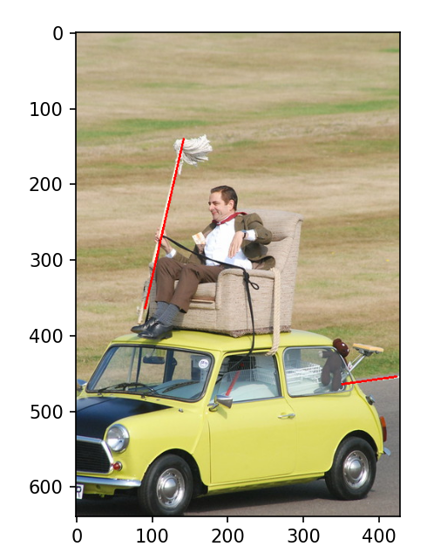

**Step**

First make sure that the lines we are interested in are identified by adjusting the parameters in "#find lines"( Hough transform).

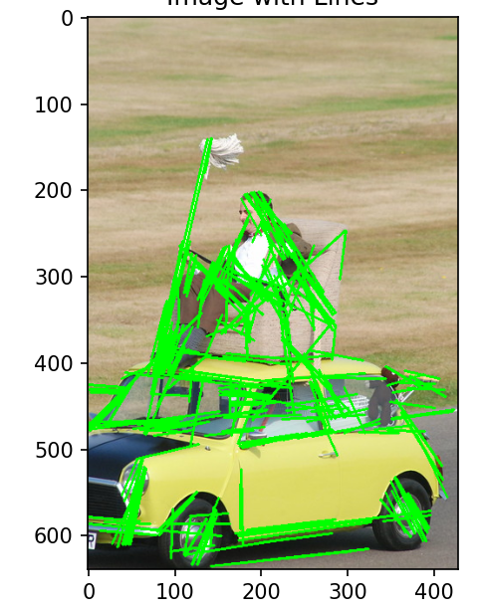

Then we look at the edge of the road and see that it is the line closest to the right. The broom is within a certain area.

Now the logic becomes clear

Finally, display both the image and the found segments

**Code**

import cv2

import numpy as np

import matplotlib.pyplot as plt

# load image

image_path = 'MrBean/MrBean2024.jpg'

image = cv2.imread(image_path)

if image is None:

    print("Image not loaded")

    exit()

# original image

plt.imshow(cv2.cvtColor(image, cv2.COLOR_BGR2RGB))

plt.title('Original Image')

plt.axis('on')

#plt.show()

#grayscale

gray_image = cv2.cvtColor(image, cv2.COLOR_BGR2GRAY)

plt.imshow(gray_image, cmap='gray')

plt.title('Grayscale Image')

plt.axis('on')

#plt.show()

# Edge Detection, Hough Transform

edges = cv2.Canny(gray_image, 50, 150, apertureSize=3)

plt.imshow(edges, cmap='gray')

plt.title('Edge Detection')

plt.axis('on')

#plt.show()

# find lines

lines = cv2.HoughLinesP(edges, 1, np.pi / 180, threshold=40, minLineLength=40, maxLineGap=10)

# Check lines

if lines is not None:

    line_image = np.copy(image)

    max_x = 0  #  maximum x value (overall rightmost line)

    min_x_in_range = float('inf')  # minimum x value (leftmost line in the specified range)

    rightmost_line = None  # rightmost line

    leftmost_line_in_range = None  # leftmost line in the specified range

    for line in lines:

        x1, y1, x2, y2 = line[0]

        # Update overall rightmost line

        if max(x1, x2) > max_x:

            max_x = max(x1, x2)

            rightmost_line = line

        # update leftmost line in the specified range if any endpoint is in the range

        if ((100 <= x1 <= 150 and 100 <= y1 <= 190) or (100 <= x2 <= 150 and 100 <= y2 <= 190)):

            if min(x1, x2) < min_x_in_range:

                min_x_in_range = min(x1, x2)

                leftmost_line_in_range = line

    # overall rightmost line in red

    if rightmost_line is not None:

        x1, y1, x2, y2 = rightmost_line[0]

        cv2.line(line_image, (x1, y1), (x2, y2), (0, 0, 255), 2)

    # leftmost line in the specified range in red

    if leftmost_line_in_range is not None and leftmost_line_in_range is not rightmost_line:

        x1, y1, x2, y2 = leftmost_line_in_range[0]

        cv2.line(line_image, (x1, y1), (x2, y2), (0, 0, 255), 2)

    # display the image and lines

    plt.imshow(cv2.cvtColor(line_image, cv2.COLOR_BGR2RGB))

    plt.axis('on')

    plt.show()

else:

    print("No lines were found")

# Q4

## Part 1

Each pixel consists of three colours, each of colour can be divided into 256 intensities (0-255), so there are 256^3 possibilities.

We have 256*256 pixels in total.

So, the total cardinality is 256*256*256^3 =1.099511628*10^12

## Part 2

Each color can be represented as a combination of three values (Red, Green, and Blue), the dimensionality is the number of pixels times three. 256*256*3=196608

8 bits are required for each dimension (total 256, from 0-255).